UN-CS-RAI-USAA-DB01-2005-00096
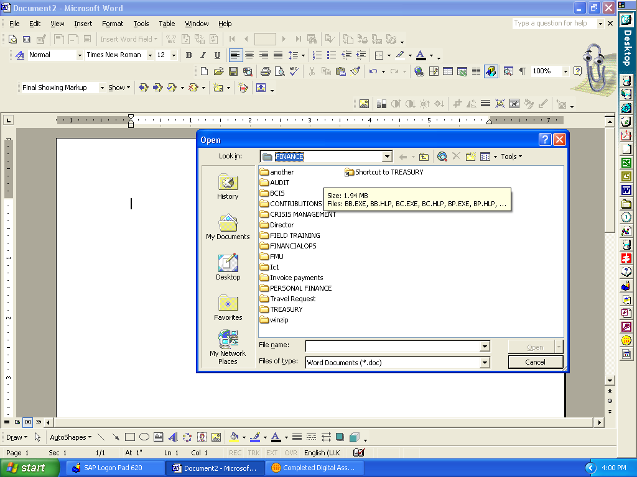

Shared drive in the Finance Section, UNICEF

